Lab Experiment: Basic Image Handling and Processing Operations
Experiment No: 4
Aim
To read an image using Python and perform image dilation using the dilate() function in the OpenCV library.
Tools Required
- Python 3.x
- OpenCV (cv2)
- NumPy
- VS Code / PyCharm / Jupyter Notebook
- Input Image

Procedure
- Install the OpenCV library using:
pip install opencv-python
- Import the required libraries (cv2 and numpy).
- Read the input image using cv2.imread().
- Create a kernel using numpy.ones().
- Apply the cv2.dilate() function to dilate the image.
- Display the original image and the dilated image.
- Wait for a key press and close all image windows.

Code
import cv2
from matplotlib import pyplot as plt

# Step 1: Read the image
img = cv2.imread("sample.jpeg")

# Check if image is loaded
if img is None:
print("Error: Image not found")
exit()
# Step 2: Convert to Gray-scale (Histogram equalization works on gray images)
gray = cv2.cvtColor(img, cv2.COLOR_BGR2GRAY)
# Step 3: Apply Histogram Equalization
equalized = cv2.equalizeHist(gray)
# Step 4: Save the result
cv2.imwrite("equalized_image.jpg", equalized)
# Step 5: Compare Original and Equalized images
plt.figure(figsize=(8,4))
plt.subplot(1,2,1)
plt.title("Original Image")
plt.imshow(gray, cmap='gray')
plt.axis('off')
plt.subplot(1,2,2)
plt.title("Equalized Image")
plt.imshow(equalized, cmap='gray')
plt.axis('off')
plt.show()
Output
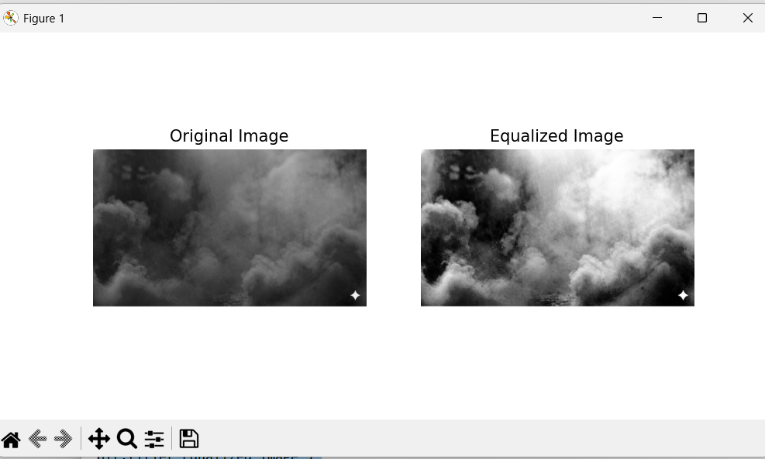
Result
The input image was successfully read using Python, and the cv2.dilate() function was used to perform image dilation. The dilated image with thicker edges was displayed successfully.

